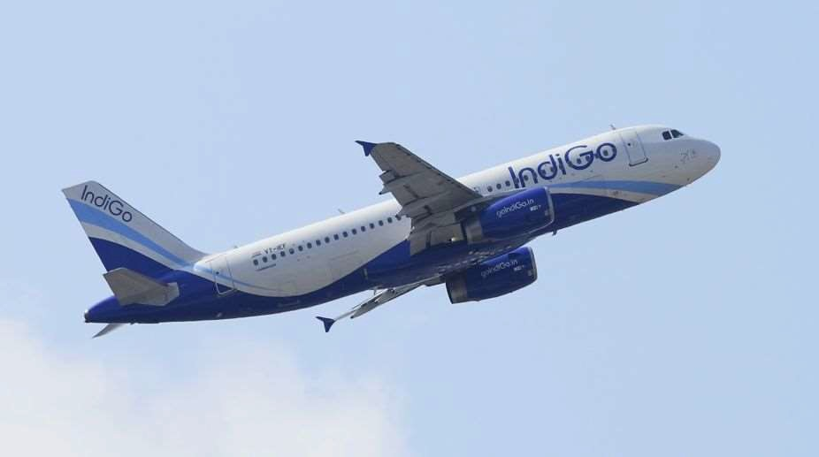

HANDLING FLIGHT DISRUPTION

Solution Design Document Version:1

Document Information
Project Name: | HANDLING FLIGHT DISRUPTION
Prepared By: |  | Document Version No: | 1
Title: | Solution Document | Document Version Date: | May 30, 2024
Reviewed By: |  | Review Date:

Distribution List
Name | Email | Role

*

Document Version History
Version  Number | Version  Date | Revised By | Description | Filename
1 | May 30, 2024 |  | HANDLING FLIGHT DISRUPTION. | SolutionDocument.doc

Contents
1. Introduction 5
1.1. Purpose 5
1.2. Scope 5
1.3. Definitions, Acronyms and Abbreviations 6
1.4. Summary of Existing Functionality 6
1.5. Requirement Details 6
1.6. Reference Documents 6
2. Business Architecture: Capability Map 7
2.1. Capability Map: Level 1 7
2.2. Capability Map: Level 2 8
2.3. Application Impacted 10
3. GENERAL OVERVIEW AND DESIGN GUIDELINES/APPROACH 13
3.1. ASSUMPTIONS / CONSTRAINTS / STANDARDS 13
3.2. ALIGNMENT WITH TARGET ARCHITECTURE 13
4. Architecture Design 13
4.1. Impact Analysis 13
4.1.1 Current Architecture 13
4.2. High Level Designs 14
4.3. Low Level Design 15
4.4. System Integration Design 23
4.5. Security Design 23
4.6. Deployment Design 23
4.7. Tech Stack 23
5. Non-Functional Requirements 24
5.1. Archiving 24
5.2. Logging 24
5.3. Auditing 24
5.4. Scalability 24
5.5. Fault Tolerance 24
5.6. System Management and Monitoring 24
5.7. User Role and access Management 24
6. Appendices 24

Introduction

Purpose
The purpose of this project is to manage flight disruptions effectively. The primary objective is to create a re-accommodation engine to perform involuntary re-accommodation of passengers on the best suited alternate flights for specific scenarios. The scenarios addressed include -
- Flight cancellation – Re-accommodate all passengers.
- Flight Reschedule – Re-accommodate passengers having misconnections.

The focus for Phase I is the operational window from D-48 to D-72 hours.

The purpose of this document is to provide the technical design and solution approaches to manage flight disruptions effectively using .NET Core as the backend framework, React.js as the frontend library, Navitaire API for flight-related functionalities, Apache Kafka for event-driven communication, and a SQL database for data storage.
It aims to provide a detailed framework for the system’s architecture, ensuring efficient performance and scalability.

Scope

The following features are in scope.
  - Provide OCC users to define exception flights which are not required to be handled by the re-accommodation engine.
  - Provide option to OCC users to map disrupted flight (“from flight”) to a specific “To” flight. In this case all PNRs will be moved to the specified “To” flight.
  - Provide option for the user to define rules for PNR prioritization.
  - Provide option to the user to define exceptional SSRs. No re-accommodation to be processed for PNRs having SSRs listed in exception list.
  - Provide option to the user to configure delay and preponement window for flights.
  - Provide option to the user to configure search period In days for which flights in future will be searched for.
  - Provide option to the user to configure number of seats not to be considered for re-accommodation on alternate flight.
  - Provide option to view exception flights entered.
  - Provide option to the OCC user to view disrupted flights, status of recommendation, excluded PNRs, PNRs that could not be reaccommodated.
  - Send notification to configured stakeholders as per the configuration.
  - Notify customers on the re-accommodation.
  - Provide admin users with an option to manage user, roles and the notification configurations.
  - Re-accommodation on flights with alternate routing (Not in Phase I)
  - Integrate with WAB and Baggage Handling (Not in Phase I)
  - Integrate with Salesforce to create and close tickets.
  - Reports for excluded PNRs, PNRs affected due to process failure.
  - In application user identity can be authenticated via Azure AD authentication
  - Integrate with Apache Kafka for asynchronous communication
.

Out of Scope

  - Baggage handling.
  - Codeshare flights.
  - Handling reinstated flight after cancellation. No re-accommodation of PNRs back to original flight.
  - Handling cases where flight timings are changed back to original timings. No re-accommodation of PNR back to original flight.
  - Cost implications due to re-accommodation.
  - Check for fare classes during re-accommodation.
  - Scenarios other than disruptions due to flight cancellation, delay of at least 2 hours or advancement by at least 1 hour of departure time.
  - Issues and un-informed changes (CR) in applications/servers like Kafka, GO-NOW (Navitaire), AD account validation, Sales force, UCG and Plan B
  - Flights outside window of D-48 to D-72
  - Delay less than 2 hours and advancement of departure time with-in 1 hour.
  - Handling PNR with SSRs STCR, MEDA, BLND, DEPU, INAD, WEAP and HUM

Definitions, Acronyms and Abbreviations

Summary of Existing Functionality

Current Process: There is no automatic re-accommodation of passengers happening in the window. The current process is as below.
- Flight Cancelled in Jeppesen
- Post cancellation of flights in Jeppesen, the same is propagated to Navitaire.
- The UCG system lists the flights which are cancelled.
- The OCC user reviews the flights and triggers a notification to the customer with a Plan B link.
- The customer clicks on the link and lands on the Plan B page.
- Customers are given the alternate flights options.
- User makes flight selection and does re-booking.
- Users are also provided the option to cancel the journey and claim refund.

Requirement Details

Reference Documents
S.NO | Description | Provided By

Business Architecture: Capability Map

Capability Map: Level 1

Please highlight the applicable capability that will be enhanced by application.
Customer Engagement

Customer Interaction Experience Management (Channels)

Order Management
Marketing
Customer Lifecycle management
Airport Experience Management
Inflight Experience Management
Loyalty Management
Offer Management
Customer Service & Issue resolution

Sales

Customer Service Delivery
Cargo Management
Network Management
Fleet Management
Marketplace Management
Crew Management
Baggage Management
Operations & Dispatch Management
Health & Safety management

External Relationship & Communications
Legal, Regulatory, Risk & Compliance
Strategy & Business Management
IT Management
Procurement & 3rd Party Management
HR Management
Financial management
Corporate Enablers

Capability Map: Level 2
New
Existing
Please highlight the applicable capability as per following text: csscd (New: New application in capability, Existing: Change in existing capability area)
Customer Engagement
Customer Interaction Management (Channels)

Mobile
Web
Agent
Kiosk
Social
Chat
Sensors
EDI
Channel Planning
Channel Performance Management
Brand Management
Marketing
Campaign Management
Sales
Sales Planning
Customer Relations
Airport Experience Management
Group Booking
Payment management
Booking
Pricing
Order Management
Check in Management
Lounge Management
Customer Special Needs Management
Departure Gate Management
Arrival Baggage Area Management
Passenger Connection management
Inflight F&B, commerce
Inflight Entertainment
Inflight Experience management
Loyalty planning
Rewards
Redemption
Loyalty Management
Customer Lifecycle management
Offer Management
Yield management
Product management
Fare management
Revenue management

Account management

Customer Onboarding

Customer 360-degree view

Customer Service Management
Issue Resolution
Case Management
Service Agent Management
Customer Service Delivery

Network Management
Fleet Management
Crew Management
Operations & Dispatch Management
Health & Safety management
Inflight Operations
Schedule Management
Inventory Management
Codeshare & Partnerships
Fleet maintenance/
engineering
Fleet planning
Fleet Acquisition
Crew Training
Crew Planning
Crew Rostering
Operations control
Crew Operations
Ground dispatch service
Route Planning
Crew Health
Flight Safety
Fuelling
Load Control
Cleaning
Ramp operations
Asset management
Air dispatch service
Partner Management
Airport Relations Management
Emergency Management
Day of Operations Management
Manpower Planning & Roster
Ground Support Equipment Management
Baggage Management
Baggage Check-in
Baggage Transport
Baggage Release
Baggage Tracking
Baggage Exceptions
Baggage Screening
Cargo Management
Marketplace Management
Cargo Forwarding
Cargo Transport
Cargo Warehousing
Cargo Tracking
Seller management
Commission Management
Supply chain integration
Cargo Capacity Planning
PO Management
Ground Operations

Corporate Enablers
External Relationship & Communications
Strategy & Business Management
Legal, Regulatory, Risk & Compliance
Business Risk Management
Litigation Management
Contract Review Management
Fraud Management
IP Management
Privacy and Consumer Protection
Regulations/Legislation Management
Business change management
Transformation management
Business Performance management
Investment management
Demand management
Environment management
Facilities management
Research and Development
Market analysis
Innovation management
Customer 360 View & Insights
Strategy planning
Industrial Relations &
Public relations
Corporate social responsibility
Internal communications
Lobbying
External communications
IT Management
Procurement & 3rd Party Management
HR Management
Financial Management
Information management
Recruitment Management
Supplier / vendor
selection
Accounting & Financial reporting
Content management
Talent Management
Supplier / vendor contract mgmt
Payroll Management
Compensations & Benefits
Learning & Development
People Performance Management
Document management
Supplier / vendor relationship mgmt
Auditing

Information security mgmt.
Insurance Management
Supplier / vendor invoice management
Business intelligence & analytics
Treasury Management
Cultural Management
Purchase management
IT operations & service support
Inventory management
Knowledge management
End user computing provision

Infrastructure management

Application management

Application Impacted

- Capability refers to the Business capabilities defines ‘what’ IndiGo does to deliver outcomes required for achieving its Vision and Strategy. It is a combination of people, process, data and digital solutions) and it seamlessly orchestrate these components to deliver the required business outcomes.
- Area refers to the subset of business capability
- Application refers to the current application in the business capability area
- Application Impacted refers to the application that may impacted due to any change in existing application or deploying a new application in the business capability area. Possible values are Yes/No or blank
- Application Integration refers to the integration required by any application with other applications in the business capability area. Possible values will be Yes, No or blank
- Application Roadmap refers to the state of application. Possible values are New, Upgrade or Sunset.
- Application Type is COTS, SaaS or Custom

Core System | Application Source | L1-Business Capability | L-2 Business Capability | L-3 Business Capability | Application Integration | Application Roadmap | Application Impacted
AIMS | COTS | Customer Service Delivery | Crew Management | Crew Planning
NAVBLUE | COTS | Customer Service Delivery | Operations & Dispatch Management | Air/Flight Disptach service
HOTAC | In House | Customer Service Delivery | Crew Management | Crew Logistics
SITA Aircom | COTS | Customer Service Delivery | Operations & Dispatch Management | Operations Control
L&T | In House | Customer Service Delivery | Operations & Dispatch Management | Load Control
AMOS | COTS | Customer Service Delivery | Fleet Management | Fleet Maintenance/ Engineering
Navitaire
MCC MEL | In House | Customer Service Delivery | Fleet Management | Fleet Maintenance/ Engineering
UCG | In House | Customer Service Delivery | Operations & Dispatch Management | Operations Control
BRS | COTS | Customer Service Delivery | Baggage Management | Baggage Tracking
COPS | In-House | Customer Service Delivery | Airport Operations | Inflight F&B. Commerce
Jeppesen Ops Control | COTS | Customer Service Delivery | Operations & Dispatch Management | Operations Control
RMS | In House | Customer Engagement | Offer Management | Revenue Management | Y
AvioBook | COTS | Customer Service Delivery | Operations & Dispatch Management | Flight Dispatch
SmartKargo | COTS | Customer Service Delivery | Cargo Management | Cargo Operations
6ePort | In House | Customer Service Delivery | Operations & Dispatch Management | Load Control
Air Vision(Sabre) | COTS | Customer Service Delivery | Network Management | Route Planning
Inform | COTS | Customer Service Delivery | Operations & Dispatch Management | Ground Dispatch Service
Liquidice | COTS | Corporate Enablers | Financial Management | Treasury Management
PAX invoicing | In House | Corporate Enablers | Financial Management | Accounting and Financial Reporting
Crew Pal | In House | Customer Service Delivery | Operations & Dispatch Management | Crew Operations
MPOS (Catering App, Crew App) | In House | Customer Service Delivery | Operations & Dispatch Management | In-flight Operations
Crew Pass | In House | Customer Service Delivery | Operations & Dispatch Management | Crew Operations
Crew Portal | In House | Customer Service Delivery | Operations & Dispatch Management | Crew Operations
Staff Travel (SLT) | In House | Customer Engagement | Order Management | Booking
6e Breez | In House | Corporate Enablers | HR Management | People and Performance Management
SAP Success Factor (SAAS solution) | In House | Corporate Enablers | HR Management | People and Performance Management
CLMS | In House | Corporate Enablers | HR Management | People and Performance Management
SAP HANA | In House | Corporate Enablers | Financial Management | Accounting and Reporting
LMS | In House | Corporate Enablers | HR Management | Learning & Development
Salesforce | COTS | Customer Engagement | Customer Service Management | Case Management
WEFA | COTS | Customer Service Delivery | Health & Safety Management | Flight Safety
Group Booking | In House | Customer Engagement | Order Management | Group Booking
PAX Re-accommodation | In House | Customer Service Delivery | Operations & Dispatch Management | Day of Operation Management
BPM (New Gen) | COTS | Corporate Enablers | Strategy & Business Management | Business Performance management
IMS (Ideagen) | SaaS | Customer Service Delivery | Health & Safety Management | Audit
Comp port | In House | Corporate Enablers | HR Management | People and Performance Management
6EMyPay | In House | Corporate Enablers | HR Management | People and Performance Management
Agent Portal - New | In House | Customer Engagement | Sales | Customer Relations
6egems | In House | Customer Service Delivery | Airport Operations | Ground Support Equipment
Skywise | SaaS | Customer Service Delivery | Fleet Management | Fleet Planning
AGS | COTS | Customer Service Delivery | Health & Safety Management | Flight Safety
Codeshare | COTS | Customer Service Delivery | Network Management | Code share and Partnership
Iron Mountain | COTS | Corporate Enablers | IT Management | Document Management
Agent Portal - Old | In House | Customer Engagement | Sales | Customer Relations
EFB Control system | COTS | Customer Service Delivery | Operations & Dispatch Management | Asset Management
Skyplus | In-House | B2C | B2C |  | Y

GENERAL OVERVIEW AND DESIGN GUIDELINES/APPROACH

ASSUMPTIONS / CONSTRAINTS / STANDARDS

Process flow constraints
- OCC to update exception table whenever required before making changes in Jeppesen. System doesn’t enforce this.
Dependencies
- Changes to current Plan B feature is live and available.
Functional assumptions
- For Move Flight option like moving specific TO flight is entered in exception table, then it is assumed that both FROM and TO flights have same routing, same number of legs.
- Consider flights only in the window D-48 to D-72 hours before scheduled departure time for phase 1.
- Search alternate flights up to +(-) days manually configurable of impacted flight departure date for phase 1. (–) days field in configuration screen should be non-editable. Alternate flight search should be done only for current day and future flights. Previous day flights should not be considered.
- In case of reschedule, delay should be at least 2 hours or advance departure by minimum 1 hour for phase 1.
- Re-accommodation will be performed only from 6E-to-6E flights.
- No maximum limit on duration between two connecting flights while re-accommodating.
- If PNR has single journey, then entire journey to be re-accommodated based on origin and destination f journey.
- If PNR has multiple journeys, reaccommodate journey having impacted flight. If this causes misconnection with other journeys in PNR then re-accommodate on those journeys as well.

ALIGNMENT WITH TARGET ARCHITECTURE

- Tech stack and DB has been chosen as per architecture guideline.
- Implementing microservice based architecture utilizing the C# as backend
- Dependency Injection for managing service dependencies
- Component-based architecture following React best practices
- All the react UI will call our API through 3 scale which hosted in API gateway.
- API Integration with Navitaire v4.5.
- Proposed deployment platform is OCP.
- Code repository on GitHub
- Container based deployment through CICD.
- Kafka Topic need to be subscribed to receive events from Jeppesen.
- UCG to be used for sending notifications to customers and internal stakeholders.
- Tickets to be created in the sales force for tracking purposes.

Architecture Design

Impact Analysis
No impact.

Current Architecture
NA. This is a new system.

High Level Designs

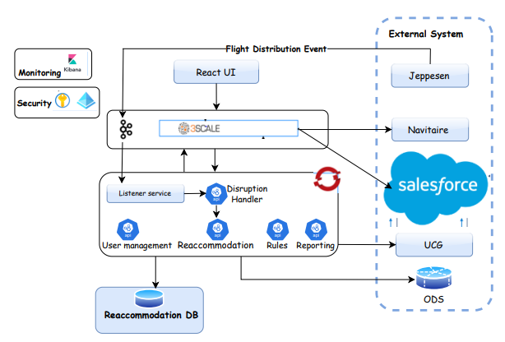

Low Level Design

Phase 1: Restriction

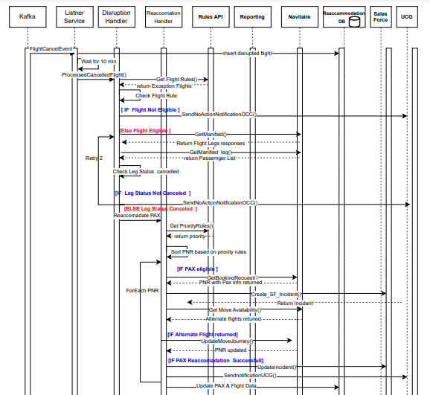

UI Screen:

UI for user administration (Create UI in next phases. In Phase 1, manage with JSON or entering data in DB manually)

- Create roles.
- Screen to create role, modify and View.
- Screen to have field – Role name, Tasks can be performed.
- Roles are Admin and Basic
- As of now, only provision needed for multiple roles but both roles are similar with same kind of access.
- Roles to be stored in database.

- Assign roles to user.
- Screen to enter username and choose role.
- User Name (Email) and Role to be stored in database.

- Screen to login.
- Email and Password to be entered.
- Validate against AD account.

UI to create exception flight list.
- Enter exception flight for which re-accommodation not to be performed. Flight details carrier code, flight number, flight suffix, flight date at origin city or range of dates, origin, and destination.
- Enter exception flight and alternate flight on to which re-accommodation to be done. In this case, re-accommodation is done on to only specified flight. Here fields are carrier code, flight number, flight suffix, date at origin and origin city for both FROM flight and TO flight.
- Enter exception flights on to which re-accommodation not to be performed. Here fields are carrier code, flight number, flight suffix, date at origin or range of dates and origin city.
- Above 3 types of exceptions can be entered with excel upload as well (if time permits in Phase I else in later phases)
- Validate if user authorized to make changes.
- Log all changes done in these screens.
- Store all exception flight details in database.
- Screen to view exception flights.

SCREEN TO CREATE

NO ACTION REQUIRED Excel Upload

Airline code

Flight Number/Suffix
Date (range) | -
Origin

Destination


Re-accommodate to specific flight Excel Upload

Disruption Flight
Airline code

Flight Number/Suffix
Date

Origin

Destination

Re-accommadation Fligt
Airline code

Flight Number/Suffix
Date


NO MOVE ONTO Excel Upload

Airline code

Flight Number/Suffix
Date (Range) | -
Origin

Destination

UI to View

Date

Origin
Destination

Type (NO ACTION REQUIRED, NO MOVE ONTO, SPECIFIC MOVE)

Report with details of flights to be displayed

UI to approve or reject re-accommodation
- Fields on screen include Carrier code, Flight Number, Suffix, date at origin city, origin- reason for re-accommodation (cancelled, delay, advanced departure time) and buttons to APPROVE and REJECT

- Validate to check if user authorized to approve or Reject

Disrupted Flights
Airline | Flight Number | Date | Org | Dest | Remarks | Approve  /Reject | Submit
6E | 111 | 30 May 24 | DEL | BOM |  | Dropdown box | Button

Provision to update configurable parameters:
(Screen required in next phases. In Phase 1, JSON object or enter data manually in DB)
- Screen to modify, view parameters.
- Minimum Connecting Time (MCT) at each airport.
- Window for flight eligibility. (D-48 to D-72). Only flight falling in this range are considered for re-accommodation.
- Number of days up to which in future / past dates flights to be searched (+- days). Flights of these days are considered for alternate flights (onto which re-accommodation will be done)
- Minimum and maximum hours of delay/advance departure. If maximum is blank, then no limit of maximum delay/advancement.
- Number of seats to be left untouched on selected alternate flight. Not to re-accommodate PNRs on to new flights to its full capacity. Specified number of seats to be left for regular bookings.
- List of SSR/items to be checked.
- Prioritize pax type for re-accommodation.
- AUTO PROCESSING – Switch to check if manual intervention needed by OCC team to proceed with re-accommodation. If AUTO PROCESSING is NO, system will proceed with re-accommodation. If YES, OCC team needs to log in and click on APPROVE button.

- Check user if authorized.
- Log all changes done on configured parameters with user who changed, date and time.
- Update database table.

Parameters
MCT Excel Upload Excel Download

Airport Code | D TO D | DO TO I | I TO D | I TO I

Window for flight eligibility
Min hours | Max hours

No of days of flights in the past/future to be searched for
Past | Future

Minimum and Maximum hours of delay
Min | Max

Minimum and Maximum hours of Departure advancement
Min | Max

No of seats to be untouched

SSRs to check |  | Excel Upload | Excel Download

AUTO PROCESSING

SUBMIT

Database Design

User Table

Column Name | Data Type | Constraint
User ID | INT | GENERATED ALWAYS AS IDENTITY
UserName | NCARCHAR(50) | NOT NULL
CreatedOn | DATE | NOT NULL
CreatedBy | VARCHAR(200) | NOT NULL
ModifiedOn | DATE | NOT NULL
ModifiedBy | VARCHAR(200) | NOT NULL

[Roles] Table

Column Name | Data Type | Constraint
Role ID | INT | GENERATED ALWAYS AS IDENTITY
Role Name | NCARCHAR(50) | NOT NULL
CreatedOn | DATE | NOT NULL
CreatedBy | VARCHAR(200) | NOT NULL
ModifiedOn | DATE | NOT NULL
ModifiedBy | VARCHAR(200) | NOT NULL

[User_Roles] Table

Column Name | Data Type | Constraint
UserID | INT | Not Null
Role ID | INT | NOT NULL

[ExceptionFlightList] Table

Column Name | Data Type | Constraint
ID | INT | GENERATED ALWAYS AS IDENTITY
Airline Code | NCARCHAR(50) | NOT NULL
FlightNumber | VARCHAR (20) | NOT NULL
FromDate | DATE | NOT NULL
ODTToDate | DATE | NOT NULL
Origin | VARCHAR (50) | NOT NULL
Destination | VARCHAR (50) | NOT NULL
NoActionRequired | bool | NOT NULL
AlternateAirline Code | NCARCHAR(50) | NOT NULL
AlternateFlightNumber | VARCHAR (20) | NOT NULL
AlternateToDate | DATE | NOT NULL
ExcelUpdate | varchar(120) | NULL
Reason | VARCHAR (3) | (NAR/NMO/MSF)
CreatedOn | DATE | NOT NULL
CreatedBy | VARCHAR(200) | NOT NULL
ModifiedOn | DATE | NOT NULL
ModifiedBy | VARCHAR(200) | NOT NULL

Disrupted Flight

Column Name | Data Type | Constraint
ID | INT | GENERATED ALWAYS AS IDENTITY
Airline Code | NCARCHAR(50) | NOT NULL
FlightNumber | VARCHAR (20) | NOT NULL
Date | DATE | NOT NULL
Origin | VARCHAR (50) | NOT NULL
Destination | VARCHAR (50) | NOT NULL
Remark | VARCHAR (50) | NOT NULL
IsApproved | bool | NOT NULL
IsReaccomadated | bool | NOT NULL
scheduledStartTime | DATE | NOT NULL
CreateddateTime | DateTime | NOT NULL
Retry | Int | NOT NULL
Source | VARCHAR (20) | (KAFKA/Manual)
CreatedOn | DATE | NOT NULL
CreatedBy | VARCHAR(200) | NOT NULL
ModifiedOn | DATE | NOT NULL
ModifiedBy | VARCHAR(200) | NOT NULL

Rule_PNR_Priority Table

Column Name | Data Type | Constraint
ID | INT | GENERATED ALWAYS AS IDENTITY
Pax type | NVARCHAR(20) | NOT NULL
Product Class | VARCHAR (50) | NOT NULL
SSR | VARCHAR (20) | NOT NULL
Priority | INT | NOT NULL
Class | NVARCHAR(1) | NULL

AppParameter

Column Name | Data Type | Constraint
ID | INT | GENERATED ALWAYS AS IDENTITY
MaxSeatLeft | INT | NOT NULL
Check_Prior_For_Availability | INT | NOT NULL(0)
Check_Next_For_Availability | INT | NOT NULL
minimum_Delay | INT | NOT NULL
preponMin | INT | NOT NULL(1)
OPW_Max | INT | NOT NULL
OPW_MIN | INT | NOT NULL
IsAutoRecommadation | BOOL | NOT NULL

KafkaTopic_Sync

Column Name | Data Type | Constraint
ID | INT | GENERATED ALWAYS AS IDENTITY
Airline Code | NCARCHAR(50) | NOT NULL
FlightNumber | VARCHAR (20) | NOT NULL
OrginDate | DATE | NOT NULL
Origin | VARCHAR (50) | NOT NULL
Destination | VARCHAR (50) | NOT NULL
scheduledStartTime | DATE | NOT NULL
CreateddateTime | DateTime | NOT NULL
Retry | Int | NOT NULL
CreatedOn | DATE | NOT NULL
CreatedBy | VARCHAR(200) | NOT NULL
ModifiedOn | DATE | NOT NULL
ModifiedBy | VARCHAR(200) | NOT NULL

AUDIT Log

Column Name | Data Type | Constraint
ID | INT | GENERATED ALWAYS AS IDENTITY
PNR | NVARCHAR(6) | NOT NULL
OrginalFlightNumber | VARCHAR (20) | NOT NULL
OrginalFlightDate | Date | NOT NULL
OrginalFlight_Orgin | VARCHAR (20) | NOT NULL
OrginalFlight_Destination | VARCHAR (20) | NOT NULL
AlternateFlightNumber | VARCHAR (20) | NOT NULL
AlternateFlightDate | Date | NOTNULL
AlternateFlight_Orgin | VARCHAR (20) | NOT NULL
AlternateFlight_Destination | VARCHAR (20) | NOT NULL
StatusofReaccomadation | VARCHAR (50) | NOT NULL(Success, partial, Failed)
ReasonForFailure | VARCHAR (50) | NOT NULL
CreatedOn | DATE | NOT NULL
CreatedBy | VARCHAR(200) | NOT NULL
ModifiedOn | DATE | NOT NULL
ModifiedBy | VARCHAR(200) | NOT NULL

System Integration Design

    - External Interfaces
- sales force
- Navitaire Services
- Navitaire ODS – to get the minimum connection time requirement for every airport.

    - Internal Interfaces

- UCG
- UCG communication distribution DB

    - External API

SNO | API | Desc | Response
1 | https://dotrezapi.test.6e.navitaire.com/api/nsk/v2/manifest?Origin=MAA&Destination=DEL&BeginDate=2024-05-24&FlightType=0 | Manifest Request
2 | https://dotrezapi.test.6e.navitaire.com/api/nsk/v1/manifest/{{LegKey}} | Manifest LegKeyRequest
3 | https://dotrezapi.test.6e.navitaire.com/api/nsk/v1/booking/retrieve/byRecordLocator/{PNR} | Get booking
4 | https://dotrezapi.test.6e.navitaire.com/api/nsk/v3/trip/move/availability | GetMoveAvailabilityRequest
5 | https://dotrezapi.test.6e.navitaire.com/api/nsk/v1/bookings/{PNR} /journey | MoveJourneyBookingsRequest | 200
6 | https://uat-azucg.goindigo.in/UCGWebService/UCGWebService.svc | UCG | 200
7

Security Design
- Azure AD Authentication
- API Authentication using JWT Token
- All data at rest is encrypted using industry standard AES-256 encryption. For data in transit, we mandate TLS 1.2 encryption or higher. While data masking can strengthen privacy protections, it would inhibit our ability to understand user intent and improve the service.
- Only internal system/service can access API calls.
- Security headers implementation in API
- Managed DB – data encryption as a native feature of managed DB.

Deployment Design

      - Front end React application to be hosted in Red hat OCP containers
      - API to be hosted in Red hat OCP containers, exposed via 3 scale gateway
      - Cron jobs to be configured for notification triggers,

Tech Stack

Backend Microservices
- .NET Core 6
- Entity Framework Core

Frontend
- React.js
- Redux
- Axios (for HTTP requests)

Database
- SQL Database

Messaging System
- Apache Kafka

Non-Functional Requirements

Archiving
Data will be archived after 30 days. Purged after 60 days.

Logging
Kibana log will be used.
logs are available for last 24 hours. Old logs in aggregated form will be stored in Kibana for 7 days.

Auditing
Audit trail will be maintained for Rules configuration.
Auditing logs are required at segment level of each data which will be maintained in DB by retaining old data.
Infra Auditing logs are captured and maintained by OCP.

Scalability
The microservices are scalable in the OCP environment.

Fault Tolerance
A mail will be sent to the respective team and business user teams in case of any failure. The current process of manual trigger by the OCC user from UCG will be available as a fallback option.

The list of PNRs that could not be reaccommodated will be sent to the stakeholders for manual intervention as required.

System Management and Monitoring
Health Check can be monitored by the OCP team.

User Role and access Management
Role access to Restrictions UI to be managed as a part of application development.
Configuration screens related to offer Engine will be accessed by Admin privilege.

Appendices
Application has dependencies on Navitaire APIs, UCG APIs, ODS database, Salesforce APIs. Any changes on these will have impact on application.

